**Experiment No. 5**

**Aim:** Setting up and supporting users: Creating user accounts, setting user defaults, modifying accounts, deleting accounts, Checking disk quotas, Sending mail to user.

1. **Creating a New User:**

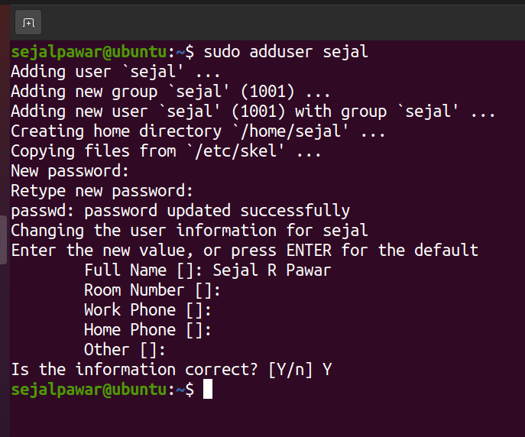

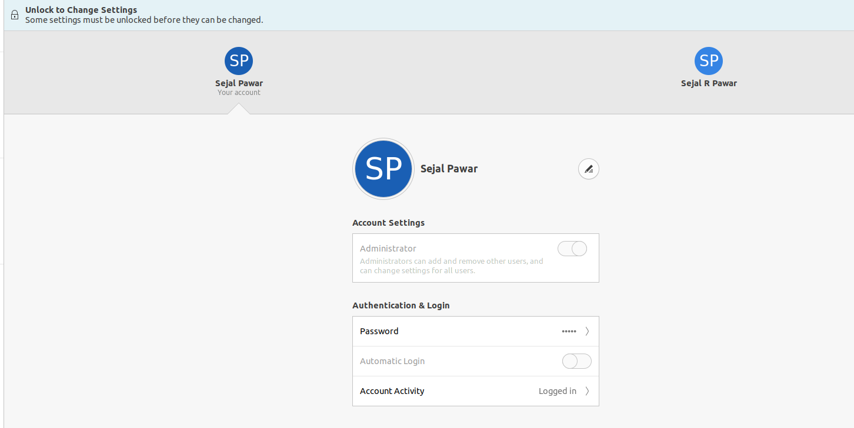

1. **Usermod and chsh utility:**

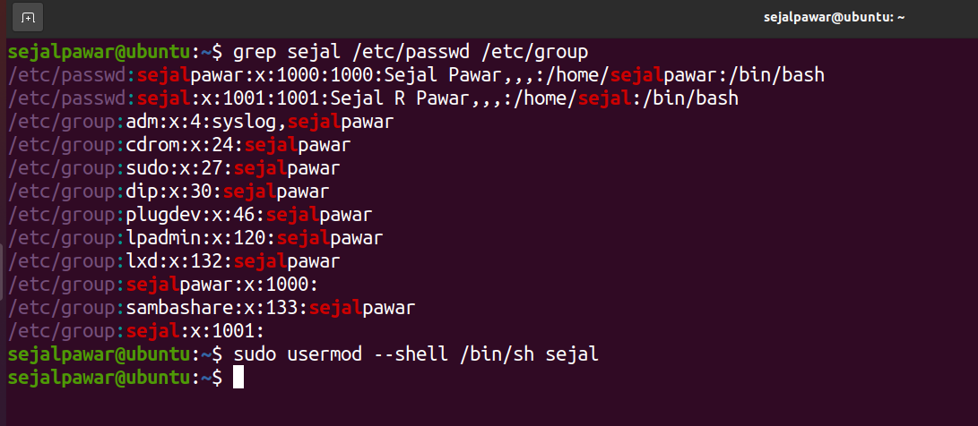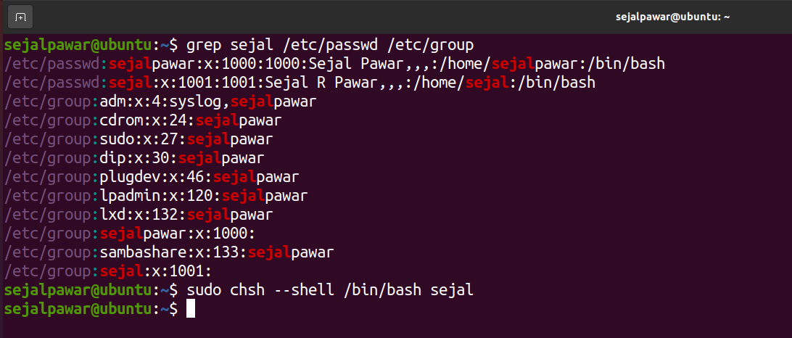

1. **vi/etc/passwd:**

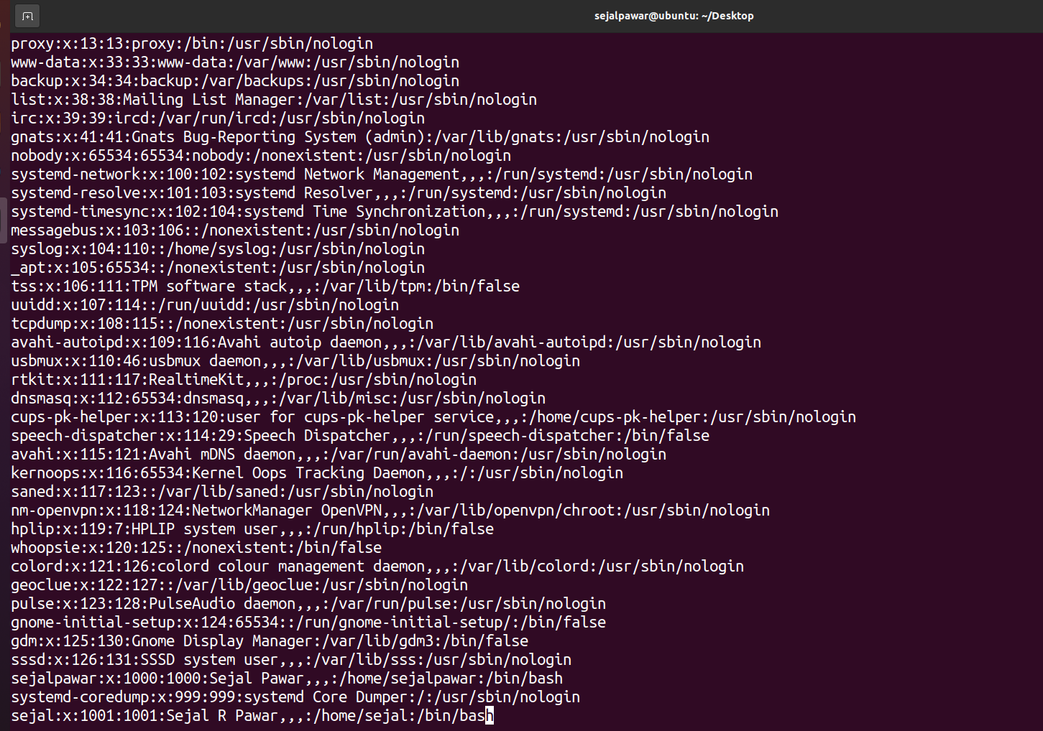

1. **Modifying Accounts:**

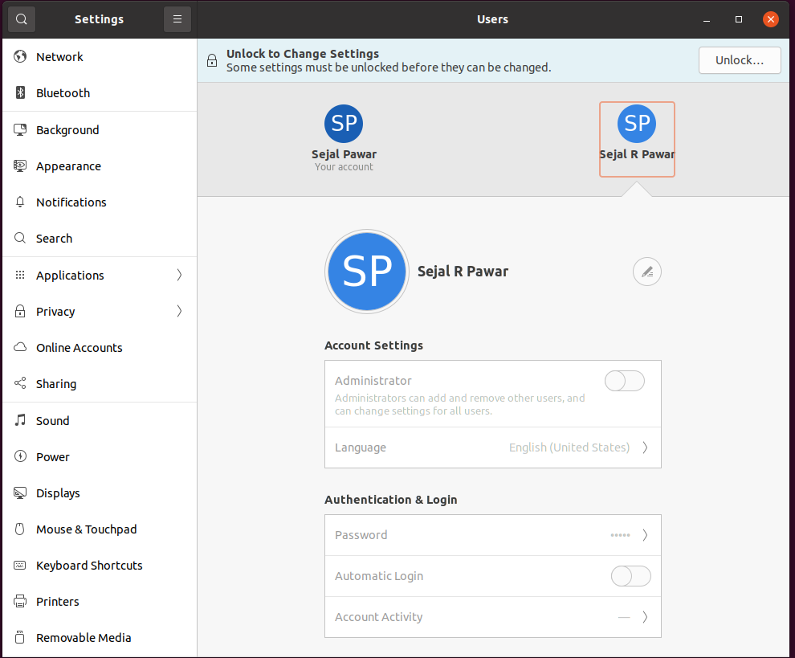

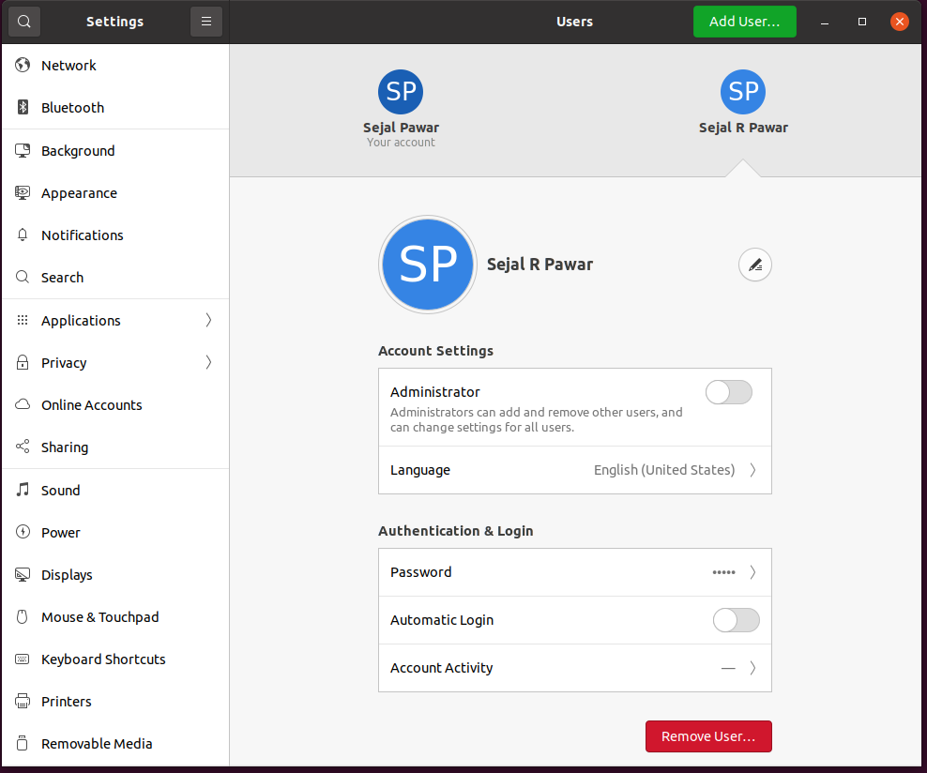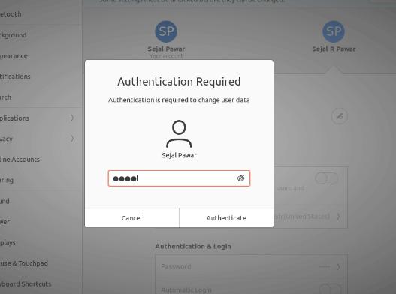

1. **Changing Username of crated account:**

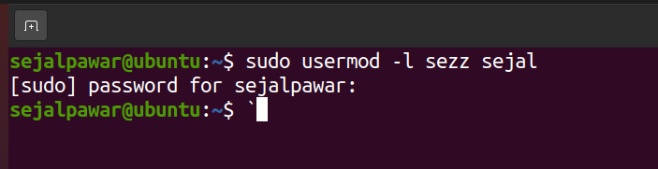

1. **Delete User:**

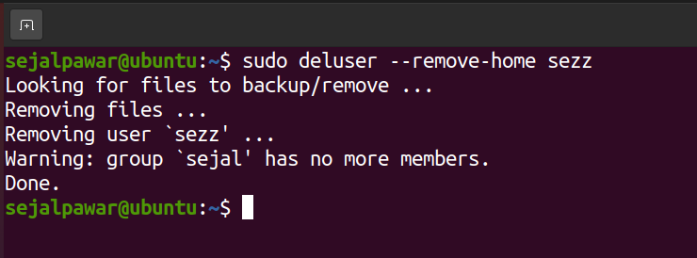

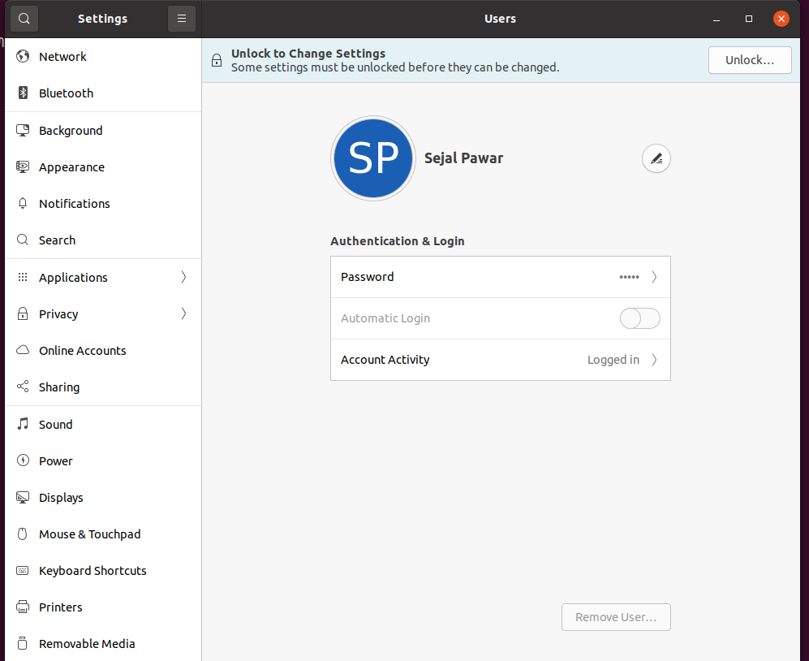

1. **To check Quota:**

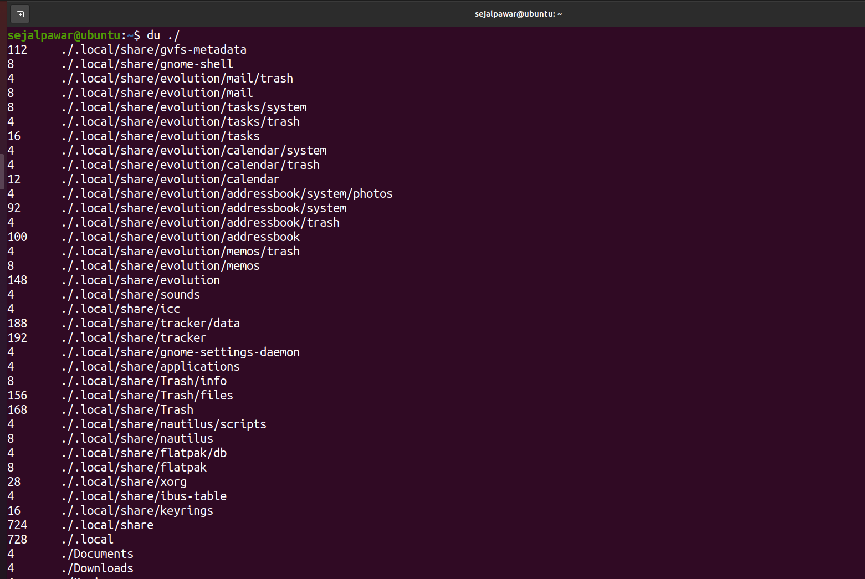

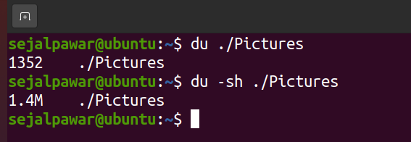

1. **To send mail:**

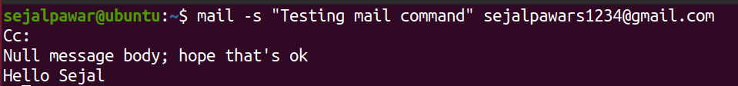

|  |  |  |  |
| --- | --- | --- | --- |
| **Practical Performance**  **(4)** | **Writeup & Oral**  **(4)** | **Attendance**  **(2)** | **Total**  **(10)** |
|  |  |  |  |